Lake Hemet Kayak & Shoreline Clean-up
Saturday, May 12, 2018
10 am - Launch from the west end of Camp 2A
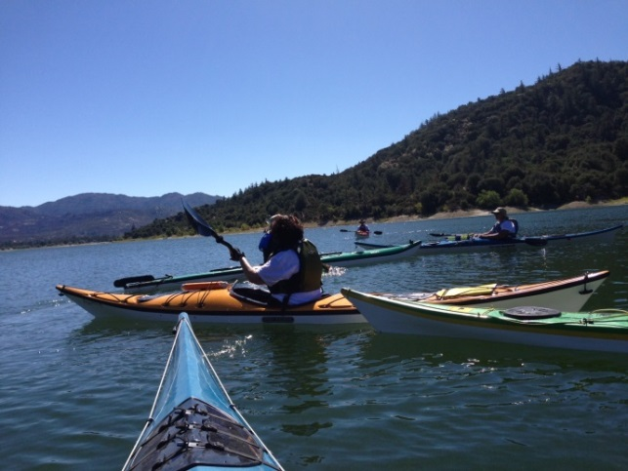
Valley Wide Kayak Club members are invited to spend a few hours paddling and collecting trash along the Lake Hemet’s south shore. Lake Hemet’s management has requested our help in cleaning up the south shoreline and will provide us with:
- Free day entry & kayak launch fees into Lake Hemet
- Free Sit on top kayaks (will be available at the Boat Marina for those
who don’t have a kayak – please allow enough time to launch and paddle around to the west end of Camp 2A to meet other paddlers)
- Trash bags
- A Pontoon boat will be at our disposal to pick up the full trash bags and bring us water
If you’ve never paddled on Lake Hemet, this is your chance to experience the beauty of this lovely mountain lake. We will be working along the shore where the lake’s two resident Bald Eagles nest and the chances are good we’ll see them and their youngsters!
Water & Sodas will be provided. Bring sunscreen, lunch, lawn chair & shade cover if you have one. We’ll have a picnic lunch on the shore at 1 pm.
If you would like to camp for the weekend, there are nice campsites available. For rates go to:
http://lakehemetrecreation.com/rates-rentals/
For more info or to sign up contact: Nancy Kutsch at NSK416@gmail.com
Directions & map on other side

Lake Hemet is located on Highway 74 just past Mountain Center, 25 miles east of Hemet and 35 miles west of Palm Desert. Check at gate entry for location of kayak clean up event. For Lake Hemet information, call
951 659-2680 or visit www.lakehemet.org
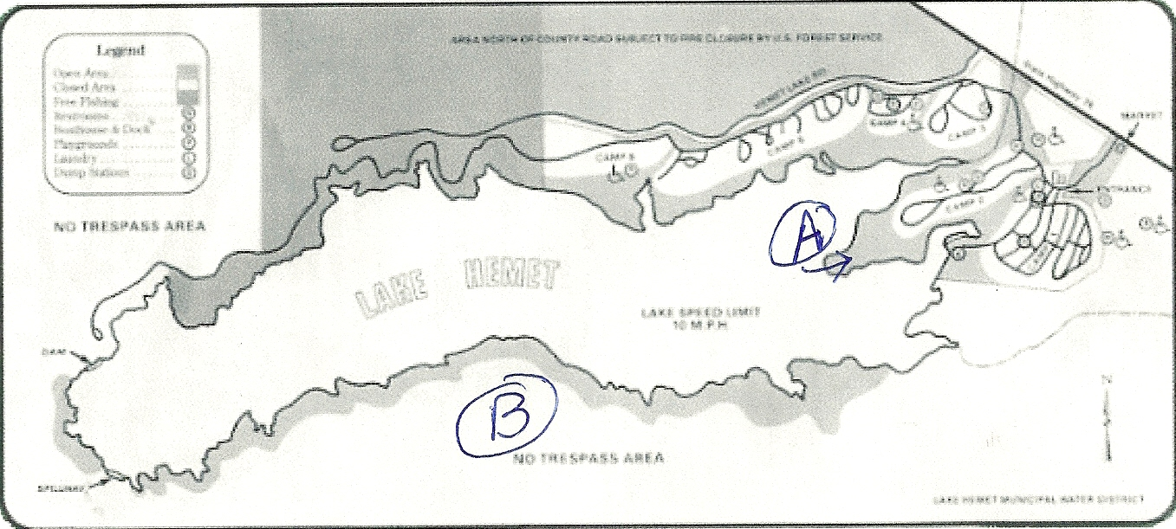
Map Legend
A: Lake Hemet Camp 2A Kayak Launch Site
B: South Shore of Lake Hemet Clean-up area

